INDIAN FOOD

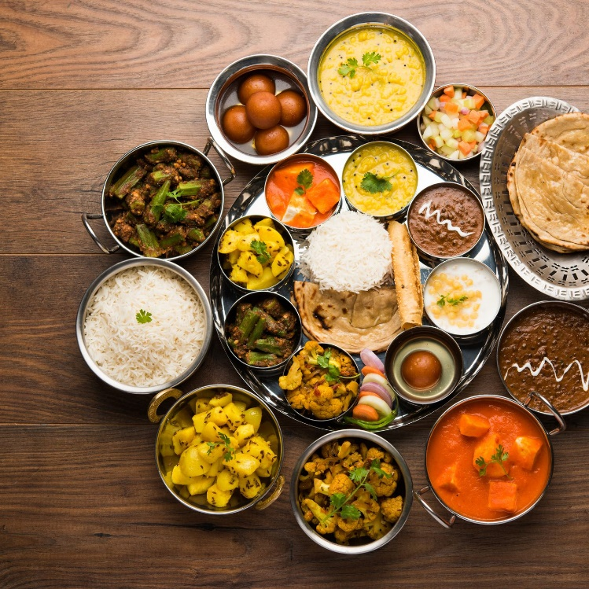

The traditional food of India has been widely appreciated for its fabulous use of herbs and spices. Indian cuisine is known for its large assortment of dishes. The cooking style varies from region to region and is largely divided into South Indian & North Indian cuisine. India is quite famous for its diverse multi cuisine available in a large number of restaurants and hotel resorts, which is reminiscent of unity in diversity. The staple food in India includes wheat, rice and pulses with chana (Bengal Gram) being the most important one. In modern times Indian pallete has undergone a lot of change. In the last decade, as a result of globalisation, a lot of Indians have travelled to different parts of the world and vice versa there has been a massive influx of people of different nationalities in India. This has resulted in Indianisation of various international cuisines. Nowadays, in big metro cities one can find specialised food joints of international cuisines.

AS I FROM SOUTH INDIA I LOVE SOUTH INDIAN FOOD…

Lets know more about south Indian food

SOUTH INDIAN CUISINE

South Indian food has earned much fame across the globe, particularly for scrumptious dishes like Dosa, Vada, Idli, Uttapam and Sambar. South Indian meals comprise cuisines of five South Indian states namely Tamil Nadu, Karnataka, Kerala, Andhra Pradesh and Telangana, along with several local cuisines within these states. The region offers a wide variety of vegetarian and non-vegetarian dishes with each state holding its own uniqueness and food habits. Some authentic and popular South Indian dishes that are sure to delight taste buds include Chakra Pongal, Sambar and Vadai from Tamil Nadu; Rava Idli from Karnataka; Kadala Curry and Appam from Kerala; and Kebabs and Biryanis from Andhra Pradesh.

South India is known for its varied range of spices, many of which are being exported to different nations for centuries. The most important spices produced in South India are cinnamon, cardamom, nutmeg, cloves and pepper. The region is famous for a wide range of spicy foods with each state differing others predominantly from the spiciness of food, its different varieties and method of cooking. The staple food of locals of the region including some Brahmin communities is rice which is best savoured with Sambhar or curry.

Tampering of different South Indian dishes remains almost the same with primary ingredients being mustard seeds, red chillies, curry leaves and oil among others. Availability of different root tubers, coconut and huge variety of fish has witnessed use of such items in various regional dishes. Ingredients like chana dal, urad dal, plantain, tamarind, ginger, garlic, coconut and snake gourd along with fresh green chillies and dried red chillies are used extensively in preparing South Indian cuisines.  Ragi (Eleusine coracana) also forms a staple diet in southern Karnataka while in northern Karnataka and Telangana, jowar (Sorghum) and bajra (Pearl millet) are consumed widely.